**Binary Search Tree**

1. Binary search tree bhi same binary tree ke jaisa hota hai but isme bas difference itna hai ki binary tree jab hum banate hai to jo elements hum insert karte hai wo koi bhi order me kar dete hai matlab uska koi specific rule nahi hota but binary search tree me hum jab element insert karte hai to ek rule hota hai ki har node ke left me usse chota element hoga and har node ke right me usse bada element hoga
2. Ab agar humare pass binary tree tha to hume binary search tree ki jarurat kyu padi because binary tree me hum elements koi bhi order me dal dete hai to agr isme searching wagera karna pada to hum O(n) time lag jayega but binary search me elements order me hote hai to ye kaam humara less than O(n) time me hojayega
3. Ab suppose humare pass aisa element aaya jiski value node ke value ke equal hai to ab hum isse kaha insert karenge left me ya right me to iska ans hai hum usse kahi bhi insert kar sakte hai ya to left me ya to right me but agar humne usse right me insert kiya to aage jake jitne bhi aise case honge jab values node se equal hai to hum usse right right me hi dalna padega because pehele humne usse right me dala hai and ye values ko right ya left me dalne ko hum left bias and right bias kehte hai
4. Ab agar humne koi binary search tree banaya and hume check karna hai ki wo binary search tree humne jo banaya hai wo right bhi hai ya nahi to ye check karne ke liye uska inorder traversal nikal lo jab bhi inorder traversal nikalo ge to jo element tumhe milega wo sorted order me milega
5. Hum tree me jab traversal karte hai to agar hum usse node pe pehele pahuche to usse likh lo ye pre-order me hum karte hai and agar uss node pe hum dusari baar pahuche tab usse likho ye hum inorder me karte hai and agar hum uss node me 3rd time pahuche to usse likh lo ye hum post order me karte hai and jab bhi hum inorder , preorder , postorder nikalte hai to ye ensure kar lena cahiye ki har node ke 2 children ho agr already hai to chod do and agar nahi hai to usse dummy children de do
6. And ek aur baat binary search tree me jo bhi humare left me corner me sabse niche wala element hoga wo uss tree ka sabse least element hoga and right me jo sabse corner me niche element hoga wo uss tree ka sabse bada element hoga
7. Ab agar hum binary search tree me kisi element ko find karna hai and ye binary search tree agar balanced hai to hum log(n) time lagege and ye binary search tree me level bhi log(n) hoga but ye hum balanced binary tree ki baat kar rhe hai balanced matlab har node ke 2 child ho tab ye time lagega

**Traversal**

Preorder – root left right

Inorder – left root right

Postorder – left right root

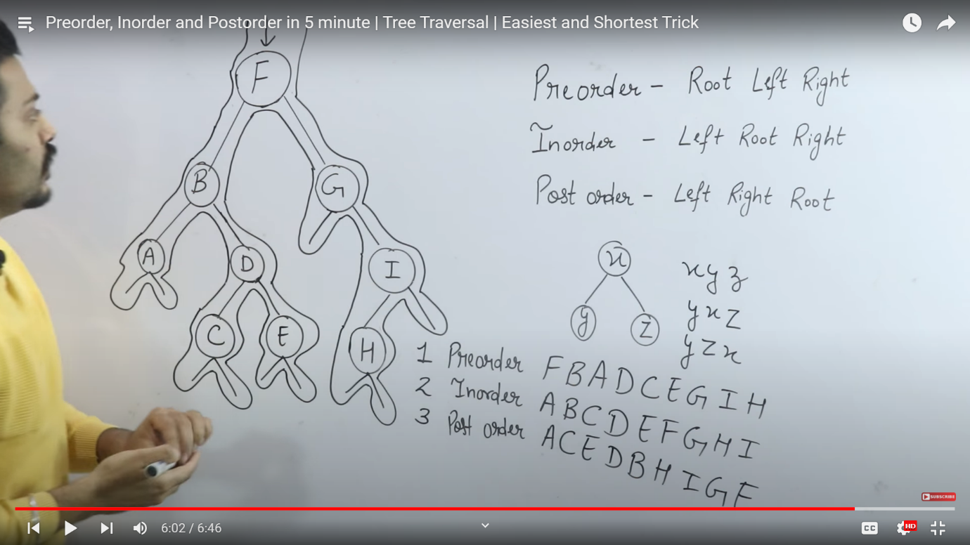

Ye image me ache se explain kiya hai ki preorder postorder and inorder kaise nikalte hai

Sab pehele iss binary tree ko complete binary tree bana lo matlab ki har nood ke 2 children hone cahiye agar already hai to chod do and agar nahi hai to unhe dummy children de do

Then ab root node se start karo and left me traversal karo and traversal karte karte apne inorder postorder preorder likhte raho